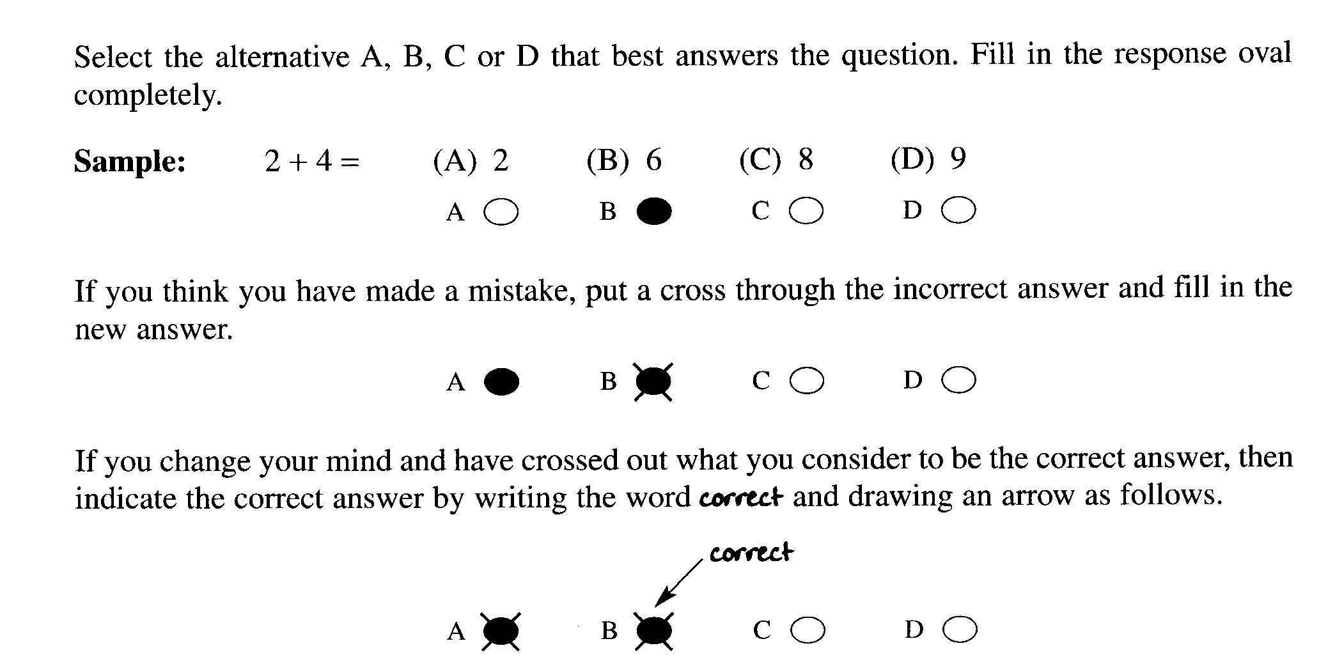
Section A: Multiple Choice (1 mark each)

Write your answer on the response grid on page 2

1.Which statement is correct concerning the use of a catalyst in the Haber Process?

(A) The catalyst enables a lower reaction temperature to be used.
(B) The catalyst produces ammonia of greater purity.
(C) The catalyst speeds up the forward reaction and slows down the reverse reaction.
(D) The catalyst removes ammonia from the product mixture allowing the equilibrium to shift to the right.

Answer – (A)
Outcome – H8

2. What is the name of the compound below?

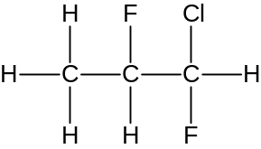

(A) 1-chloro-1,2-difluoropropane
(B) 3-chloro-2,3 – difluoropropane
(C) 1,2-difluoro-1-chloropropane
(D) 1-chloro-1,2-fluoropropane

Answer: A
Outcome(s): H9
3. Which conditions would Le Chatelier advise for the maximum production of ammonia

(A) low pressure and low temperature
(B) low pressure and high temperature
(C) high pressure and low temperature
(D) high pressure and high temperature

Answer – (C)
Outcome – H8
4. Sydney Water tests a sample of water at Warragamba Dam. The results are shown in the table…

Aluminium  (μg L ^{–1}) | Total chlorine  (mg L ^{–1}) | Fluoride  (mg L ^{–1}) | Iron  (μg L ^{–1}) | Manganese  (μg L ^{–1})
< 10 | 1.52 | 1.11 | < 20 | 6

Which chemical species could be efficiently assayed using AAS?

(A) Total chlorine
(B) Total chlorine and fluoride
(C) Aluminium, iron and manganese
(D) Aluminium, total chlorine, fluoride, iron and manganese

Answer – (C)
Outcome – H4

5. What is the purpose of adding chlorine to domestic water supplies?

(A) To reduce the pH of the water
(B) To remove the heavy metal ions like lead from the water.
(C) To clarify the water
(D) To disinfect the water

Answer:D
Outcome(s): H4, H8

6. In which layer of the atmosphere does ozone act as a UV radiation shield?

(A) mesosphere
(B) stratosphere
(C) thermosphere
(D) troposphere

Answer: B
Outcome(s): H6

Section A

Multiple Choice Answer Grid
1. A B O C O D O

2. A  B O C O D O

3. A O B O C  D O

4. A O B O C  D O

5. A O B O C O D 

6. A O B  C O D O

Section B: Short Answer Questions

Question 7 (6 marks)

The Syntex Ammonia Corporation produces ammonia via the Haber process by mixing hydrogen and nitrogen in a 3:1 mole ratio and passing it over a promoted iron catalyst at 500°C and 200 atm. Under these conditions the yield of ammonia is 20%.

The graph shows a pair of lines for the reaction of hydrogen and nitrogen during the synthesis of ammonia…
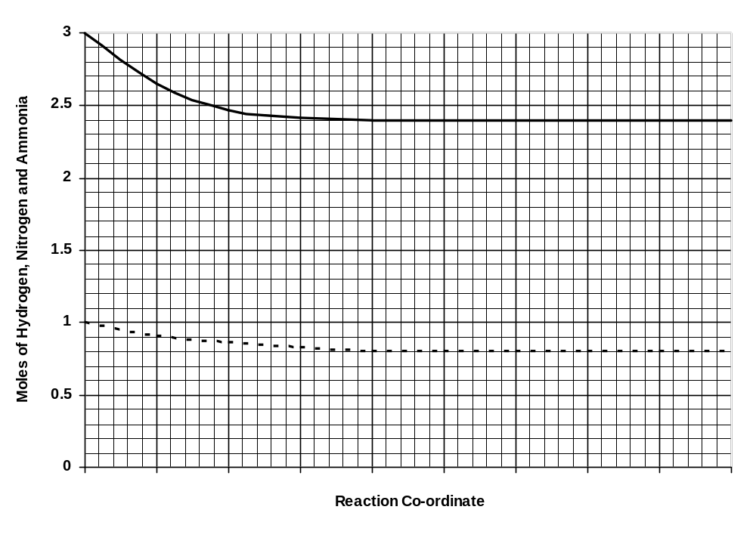
Hydrogen
Nitrogen

(a) Indicate on the graph the amount of ammonia during the same period by drawing
in a line showing the simultaneous production of ammonia during the process (2 mark)

(b) Explain the effects of temperature on the rate of production and yield of ammonia. (4 marks)

______________________________________________________________________________

______________________________________________________________________________

______________________________________________________________________________

______________________________________________________________________________

______________________________________________________________________________

______________________________________________________________________________

______________________________________________________________________________

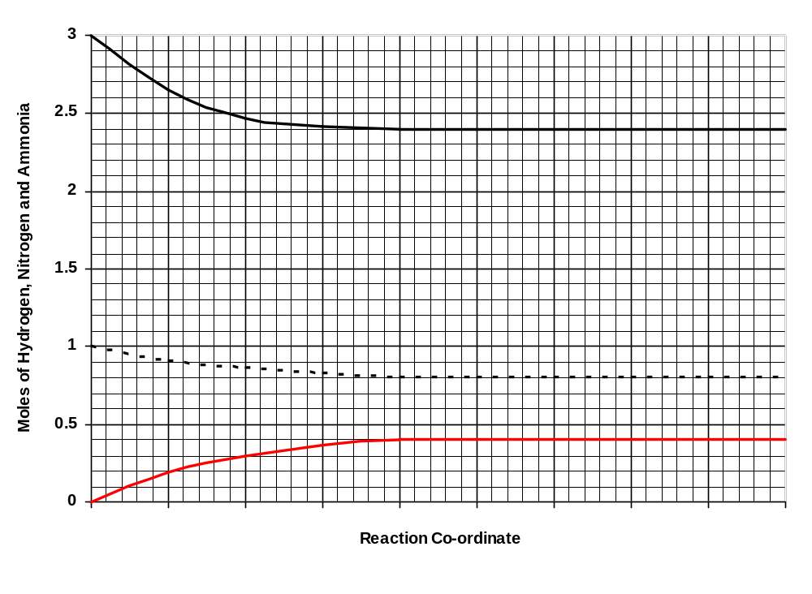
Hydrogen
Nitrogen

Ammonia
(a)

Answer – Ammonia line must equilibrate at 0.4 mole to match hydrogen and nitrogen lines. (1 mark)
Outcome – H10

(b) Explain the effects of temperature on the production of ammonia. (4 marks)

Outcome – H8

Temperature has a dual effect on the production of ammonia.

(1) An increase in temperature will increase the reaction rate (1 mark) because more molecules will have more energy to exceed the activation energy (1 mark).

(2) According to Le Châtelier’s Principle, an increase in temperature will favour the endothermic reaction and shift the equilibrium to the left (1 mark), resulting to reduced ammonia production (1 mark).

(c) In 1918 Fritz Haber was awarded the Nobel Prize for the ammonia production process.
What was the greatest benefit of this process? (1 mark)

______________________________________________________________________________

______________________________________________________________________________

______________________________________________________________________________

______________________________________________________________________________

During the era of the Haber Process, scientists predicted the exhaustion of Chilean reserves of natural nitrate fertiliser would result in greatly lower agricultural production and possible famine. The Haber Process enabled the cheap production of ammonia which could be easily oxidised to produce synthetic nitrates.

Outcome – H4

Question 8 (7 marks)

Mount Ruse® Mineral Water is analysed for the presence of iron, chloride and carbonate ions.

(a) Complete the table showing suitable test reagents and results… (6 marks)

Ion tested | Test reagent used  (name or formula) | Observed result for a positive test
iron (III)
chloride
carbonate

Ion tested | Test reagent used  (name or formula) | Observed result for a positive test
iron(II) | K₃Fe(CN)₆ _{(aq)} | Blue colouration forms | 1 mark
iron(II) | NaOH _{(aq)} | Green precipitate forms | 1 mark
iron(III) | K₄Fe(CN)₆ _{(aq)} | Blue colouration forms | 1 mark
iron(III) | KSCN or NH₄SCN | Blood red colouration forms | 1 mark
iron(III) | NaOH _{(aq)} | Brown precipitate forms | 1 mark
chloride | AgNO₃ _{(aq)} | White precipitate forms | 1 mark
carbonate | HNO₃ _{(aq)} | Effervescence | 1 mark

Outcome – H8, 11

(b) Mount Ruse® Mineral Water is also known to contain calcium ions.
Describe a simple test to detect calcium which does not involve a test reagent. (1 mark)

_________________________________________________________________________________

_________________________________________________________________________________

A positive flame test for calcium ions would be indicated by an orange/brick–red colouration.

Outcome – H11

Question 9 (4 marks)

(a) Describe what is meant by a coordinate covalent bond.

…………………………………………………………………………………………………………..

……………………………………………………………………………………………………………

(b) Circle the covalent bond in the diagram of ozone.

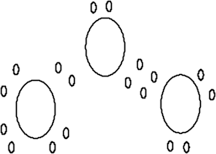

(c) Identify the type of diagram used in question (b) above.

…………………………………………………………………………………………………….

…………………………………………………………………………………………………….

(d) The diagram used in question (b) above is one way to model a molecule of ozone. State one
limitation of such a model

………………………………………………………………………………………………………

………………………………………………………………………………………………………

Outcome(s): H4, H6
Criteria | Marks
a) correctly defines coordinate covalent bond | 1
b) correctly circles coordinate covalent bond | 1
c) correctly identifies Lewis dot diagram | 1
d) correctly states 1 limitation of modelling | 1

Sample answers:

(a) A coordinate covalent bond is one in which both of the shared electrons come from the one atom

(b)

(c) Lewis dot diagrams

(d) One limitation of this model is that it is only a representation of the molecule and is not indicative of
its size or its 3D nature.

Question 10 (5-marks)

The concentration of chromium in an aqueous sample was determined by pipetting 10.0 mL of the sample into a 50.0-mL volumetric flask and diluting to volume. The solution was measured by atomic absorption along with four standard solutions of chromium. The results are given in the table.

Sample | Concentration, ppm | Absorbance
Standard A | 2.4 | 0.091
Standard B | 4.8 | 0.177
Standard C | 7.2 | 0.266
Standard D | 9.6 | 0.353
Unknown Cr | Unknown | 0.201

(a) Draw a graph of the data. (2 marks)


A
B
S
O
R
B
A
N
C
E

CONCENTRATION (ppm)

(b) Use the graph to calculate the concentration of Cr in the original sample in. (3 marks)

(i) ppm ……………………………………………………………………………………..

……………………………………………………………………………………….

(ii) mol L⁻¹ ……………………………………………………………………………………..

……………………………………………………………………………………….

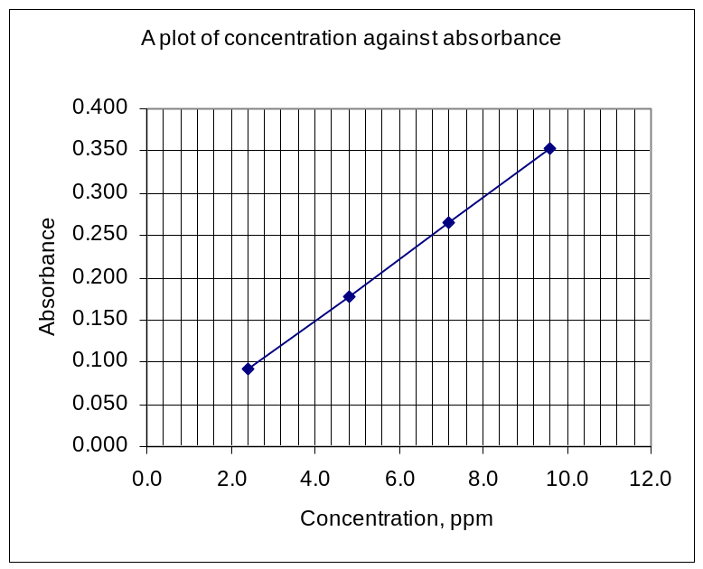

Marking:
1 mark for axis labels
1 mark for points correctly plotted

(b) Calculate the concentration in mol L ^{–1} of Cr in the original sample. (3 marks)

ANS
From the graph, the concentration in ppm of the unknown is 5.3 ppm (1 mark)
The concentration of Cr in the original sample is 5.3 ppm x 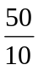 = 26.5 ppm (1 mark)
in mol L⁻¹ Cr = 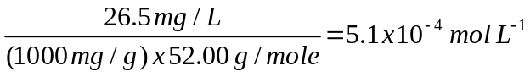

Question 11 (6 marks)

Given below is a diagram which represents the design of a microscopic membrane filter.
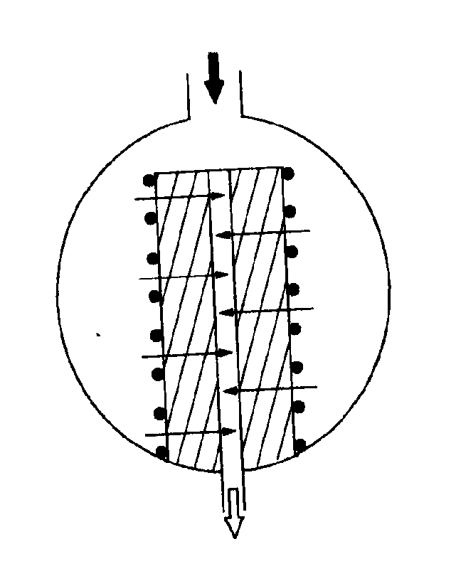
•
✪
•
•
water in
water out
dirt
.

Explain how the filter works and assess the effectiveness of this method of filtration in its use to purify
water supply

…………………………………………………………………………………………………………….

…………………………………………………………………………………………………………….

…………………………………………………………………………………………………………….

…………………………………………………………………………………………………………….

Criteria | Marks
A judgement of effective usage, a description of usage, and a good description of function | 5-6
Good explanation of function and a description of its usage | 4
Good explanation of how the filter works | 3
Adequate explanation of how the filter works | 1-2

Sample Answer:

A membrane filter is usually a thin film of a synthetic polymer through which there are pores of fairly uniform size. These pores can be very small, e.g., 0.2μm, and can filter out much smaller particles than sand filters

The dirty water flows into the filter (black arrow) and the membrane filters out the particles (black dots) and clean water moves through the membrane and flows out of the centre of the filter (clear arrow). The filter can be easily cleaned by back flushing

These filter are very effective in water purification systems. They can filter out most particles and even giardia and cryptosporidium that caused recent health scares in Sydney water supplies. They are easily cleaned and reasonably strong and can be arranged with a large surface area for extensive water treatment.

